

Educational Visits Policy
Document History
Created or reviewed: | May 2024
Reviewing officer: | Trustees
Review frequency: | 3 yearly
Review date: | May 2027
Reviewed September 2026 – following updated training | Sept 2026

Based on North Yorkshire Outdoor Learning Model School Policy November 2022
This model policy has been reviewed to ensure consistency with the revisions made to the employer policy during November 2022.
Leyburn Primary School’s Policy for Educational Visits, Outdoor Learning and Adventurous Activities
Introduction

This policy sets out the establishment procedures within which all employees must operate. Further details can be gained by referring to the Employer Policy as detailed in Section 2.

Every young person should experience the world beyond the classroom as an essential part of learning and personal development, whatever their age, ability, or circumstances.

Learning beyond the classroom is the use of places other than the classroom for teaching and learning. It is about getting children and young people out and about, providing them with challenging, exciting, and different experiences to help them learn.

It is about raising achievement through an organised, powerful approach to learning in which direct experience is of prime importance. This is not only about what we learn but importantly how and where we learn. It is not an end in itself but a vehicle to develop the capacity to learn. Good quality learning beyond the classroom adds much value to classroom learning.

- Scope and responsibilities

This policy applies to all educational visits, outdoor learning and adventurous activities carried out with young people. It does not apply to work-experience placements, work related learning or alternative provision.

The headteacher appoints Hannah Burn as Educational Visits Co-ordinator. They will have the training and experience to enable them to competently discharge their responsibilities as listed in The Employer Policy.

The Educational Visits Co-ordinator is: Hannah Burn and Sarah Beveridge

Administrative tasks will be carried out by: Steve Vallack

- Establishment policy and procedures

The Policy for Educational Visits, Outdoor Learning and Adventurous Activities (November 2022) is the employer’s policy. YCAT recognises that it is the employer and retains responsibilities for health and safety. It will discharge its duties through the adoption of the policy and retain competent advice, approval and monitoring through North Yorkshire Outdoor Learning. Specific local procedures will be in line with, but not duplicate this policy.

Where there is conflict with non-statutory guidance or advice from other sources the employer policy will take precedence with clarification sought from the Headteacher, and if required from North Yorkshire Educational Visits Advisory Service.

Consent
Routine acknowledgement: Whilst it is not a legal requirement to gain parental consent for curriculum activities, written acknowledgement will be gained on enrolment for routine local visits and activities which are a part of our normal educational provision during the school day and information regarding the nature of the types of visits will be included in our prospectus. We will always aim to fully inform parents through Class dojo of the nature of each visit, activity, or series of a similar nature, remind parents that they have acknowledged this, and give opportunity to update information and emergency contact details. On occasions a curriculum opportunity may become available at short notice, and we will always aim to notify parents that their child will be off-site, but this may not be possible.

Non-routine consent: Written consent will be gained on enrolment for those visits which are non-routine visits and activities and those visits which fall outside of normal hours. We will fully inform parents of the nature of each visit, activity, or series of a similar nature.

Specific consent: Written consent will be gained for every individual visit, activity or series of a similar nature which involve a higher level of risk including but not limited to longer journeys, residential visits, and adventurous activities. We will fully inform parents by letter and/or Class Dojo of the nature of each visit, activity, or series of a similar nature.

Medical information: We will use the medical information on record in our Student Information Management system alongside any updated information which parents will be given the opportunity to provide for most visits and activities. Where visits or activities involve a higher level of risk it may be appropriate for separate medical information and consent forms to be completed.

Staff competence
Records will be kept of induction, training, relevant qualifications and competence using the ‘My Details’ section of Evolve.
To ensure sustainability of important visits deputy leaders will be appointed in order that contingency plans can be put in place should a visit leader be indisposed.

EVC Training
The Educational Visits Co-ordinator will attend appropriate training and revalidation as required by the employer.

Visit Leader Training
Visit leaders will be approved by the Headteacher and will have attended appropriate training as required by the employer.

- Planning and approval procedures

Visit leaders should follow the employer policy, establishment policy, guidance, local procedures, and standard assessments of risk.

Risk management is a vital part of planning and assessing benefits and risk associated with visits and activities. Sensible risk management relates to identifying significant hazards and mitigating against risk through appropriate control measures. It is not a paperwork exercise but a dynamic process before and during a visit or activity in order that young people can be kept safe from harm. At Leyburn Primary School we have identified a Local Learning Area which includes all the places that we visit and the activities that we undertake routinely. Details of our Local Learning Area are contained within the appendix which includes generic risk assessment. Wherever the need arises additional risks and significant findings will be recorded using event specific risk assessment.

External providers: Wherever possible visit leaders will gain credible assurances of health & safety management systems and quality provision through a Learning Outside the Classroom Quality Badge. Alternatively, assurances will be gained through a Provider Statement as detailed in the employer policy

- Visit Planning and Management System

Evolve is the YCAT’s web-based system used to facilitate the efficient planning, management, approval, and evaluation of visits. All staff that lead or accompany visits can access their own account which is set up by the Educational Visits Co-ordinator.

The default option is a day visit within the United Kingdom. Visits can be further categorised as follows:
- On-site or local learning area
- Joint visit
- Overseas
- Residential
- Adventurous (provider led)
- Adventurous (self-led)

Visits will be recorded as detailed in the summary table below.

Approval of visits will be made as detailed below. Initial approval in principle will also be gained as required in the employer policy.

Governing Body:
The governing body has a strategic role to set the vision and direction of the school and has responsibility for its educational and financial performance. To enable this, it will hold the Headteacher to account by oversight of learning beyond the classroom opportunities to ensure that the educational experiences are of high quality, that best value is obtained, and financial regulations are adhered to.
Additionally, as the employer, approval will be retained for visits abroad, all residential visits and all adventurous activities in line with the employer policy. The governing body delegate the approval of these visits to North Yorkshire Educational Visits Advisory Service.

Adviser: Visits abroad, residential and all adventurous activities regardless of leadership or location. (As detailed in guidance).

Headteacher: :visits abroad, all adventurous activities, residential visits, and non-local day visits

Educational Visits Co-ordinator:
Local walking visits, bike ability training, local sports fixtures, and local swimming visits

Visit planning approval summary table for Leyburn Primary School

 | Planning/Recording Process | Risk Management | Final Approval
On-site/Local Learning Area/Local Area Visits | All visits are entered onto Evolve | LLA risk management supplemented by specific documentation where necessary | EVC/Head
Day Visit outside Local Learning Area | Recorded on Evolve | School risk manages journey and non-provider led activities using LLA risk management supplemented by specific documentation where necessary | EVC/Head
Overseas | Recorded on Evolve | LLA risk management and supplemented by specific documentation necessary | Adviser
Residential | Recorded on Evolve | LLA risk management and supplemented by specific documentation necessary | Adviser
Adventure, provider led | Recorded on Evolve | Provider risk manages activities  School risk manages journey and non-provider led activities using LLA risk management supplemented by specific documentation where necessary | Adviser
Adventure, self-led | Recorded on Evolve | Local Learning Policy/Specific Risk Management | Adviser

- Incident Management

In the case of an incident during a visit all members of staff will follow the establishment’s incident management plan as detailed in the appendix.

- Monitoring of visits and procedures

Governors will monitor the implementation of this policy by acting as a critical friend in monitoring the implementation and effectiveness of the policy.

The Educational Visits Co-ordinator will ensure that there is a system in place for appropriate monitoring of visits and activities.

- Charges for Off-site Activities and Visits

Charges for educational off-site visits and adventurous activities, including charges for visits and transport, requests for voluntary contributions and remission of charges are made in line with DfE guidance. Reference should also be made to YCAT charging and remissions policy.

- Inclusion & SEND

We endorse the principles for young people of a presumption of entitlement to participate, accessibility through direct or realistic adaption or modification and integration through participation with peers.

We acknowledge that it is unlawful to treat a young person with a protected characteristic less favourably or fail to take reasonable steps to ensure that young people with protected characteristics are not placed at a substantial disadvantage without justification.

We also acknowledge that expectations of staff must be reasonable, so that what is required of them (to include a young person) is within their competence and is reasonable. Reference should also be made to Leyburn’s SEN policy.

- Safeguarding

Safeguarding procedures should be considered as part of the planning process with additional consideration for residential visits. Visit Leadership Teams should:
- As part of planning, liaise with the Designated Safeguarding Lead (DSL) and other staff to identify any relevant safeguarding issues
- Have access during a visit to the DSL (or trained deputy) either directly or through the Base Contact.
Any volunteers who accompany any visit or activity will be vetted and be directly supervised by a member of staff. If they are to have significant unsupervised access to young people, then an enhanced DBS disclosure will be obtained and they will undergo induction and training in their role and responsibilities as detailed in employer and school policies and local procedures. Reference should also be made to Leyburn’s Child protection Policy

- Insurance

Young people participating in visits and activities will have annual travel insurance provided under an annual Schools Journey Insurance policy. Any differences to this will be notified to parents/carers as appropriate before any consent or payment is made.

- Transport

Careful thought must be given to planning transport to support off-site activities and visits. Statistics demonstrate that it is more hazardous to travel to an activity than to engage in it and staff must follow any specialist guidance provided by your employer.

Appendix – Leyburn Primary School

Local Learning Area

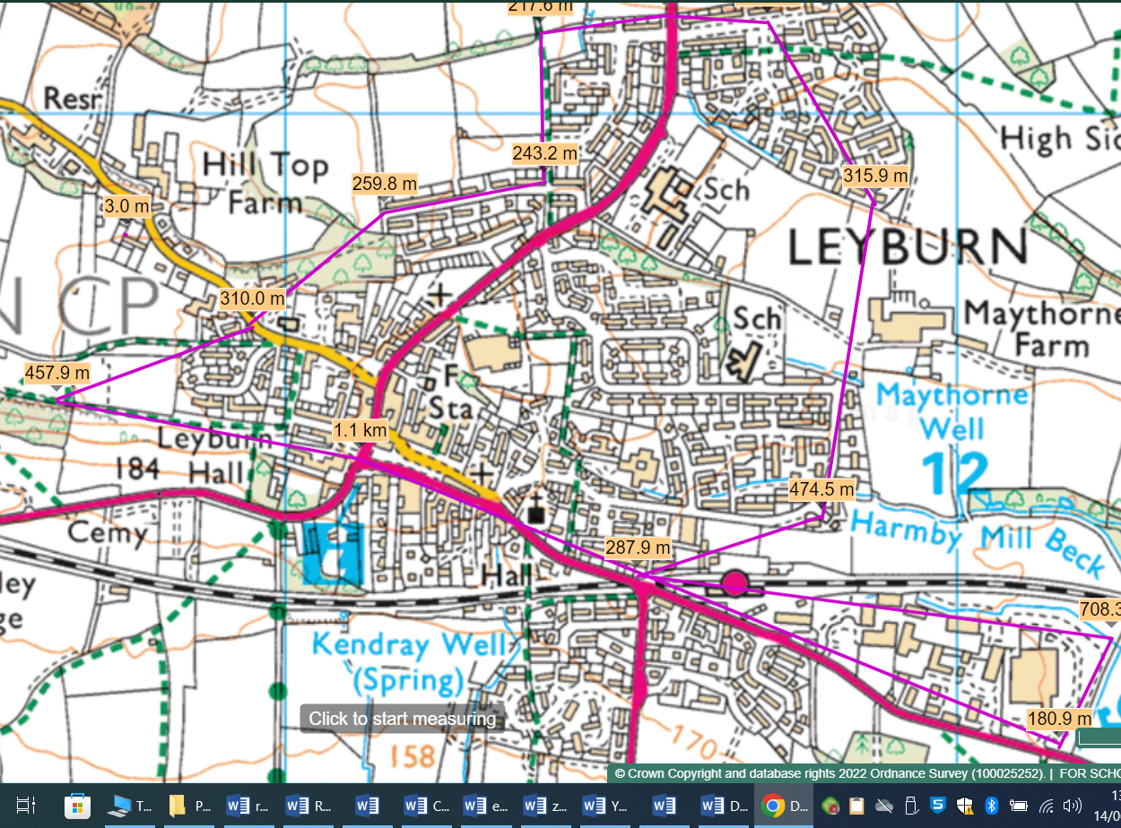

The boundaries of the locality are shown on the above map. This area includes the following frequently used venues: e.g.
- Tennants Auction Rooms
- Kirkwood Hall
- St Matthew’s Church
- The Methodist Hall
- The Market Place
- Library
- The Shawl
- Thornborough Woods

We use our Local Learning Area on a regular basis for a variety of learning activities, and visit leaders are allowed to operate in this area by inputting visits on EVOLVE using the Local Learning Area option, provided they follow the below Operating Procedure.

Swimming takes place throughout the year and currently is held at Richmond Swimming Pool. The children are transported there using a local coach company. These will be recorded using the full Evolve form for LLA.

Operating Procedure for visits to the Local Learning Area

The following are potentially significant issues/hazards within our extended locality:
- Road traffic.
- Other people / members of the public / animals.
- Losing a pupil.
- Uneven surfaces and slips, trips, and falls.
- Weather conditions.
- Activity specific issues when doing environmental fieldwork (nettles, brambles, rubbish, etc).
- Additional consideration of going around Leyburn on either Market Day or the days when the Auction Mart is on.
- Thornborough Woods will be checked before any visit.

These are managed by a combination of the following:
- The Head, Deputy or EVC must give verbal approval before a group leaves.
- Only staff judged competent to supervise groups in this environment are approved. A current list of approved staff is maintained by the EVC and office.
- The concept and Operating Procedure of the ‘Local Learning Area’ is explained to all new parents when their child joins the school.
- There will normally be a minimum of two adults although this will be amended for children in EYFS.
- Staff are familiar with the area, including any ‘no go areas’, and have practiced appropriate group management techniques.
- Pupils have been trained and have practiced standard techniques for road crossings in a group.
- Where appropriate, pupils are fully briefed on what to do if they become separated from the group.
- All remotely supervised work in the extended learning locality is done in ‘buddy’ pairs as a minimum.
- Pupils’ clothing and footwear is checked for appropriateness prior to leaving school.
- Staff are aware of any relevant pupil medical information and ensure that any required medication is available.
- Staff will deposit in the office a list of all pupils and staff, a proposed route, and an estimated time of return.
- A staff mobile is taken with each group and the office have a note of the number.
- Appropriate personal protective equipment is taken when needed (eg gloves, goggles)

Grab bag – not just First Aid Kit. Sun screen, water, bin bags, baby wipes, toilet roll etc
Agree place and procedure for crossing the road.
Consider need for high vis during any visit

